# Homework: Advanced Tree Structures - Part I

This document defines the **homework assignments** for the ["Data Structures" course @ Software University](https://softuni.bg/trainings/1147/Data-Structures-June-2015). Please submit a single zip / rar / 7z archive holding the solutions (source code) of all below described problems.

## AVL Tree

Implement an **AVL tree** by following the guidelines from the [lab document](https://softuni.bg/downloads/svn/data-structures-and-algorithms/Data-Structures-February-2016/8.%20Binary-Heap-Exercises.docx). The tree should support only **insertion** and **search** operations. Make sure all unit tests pass before you continue.

Use your AVL tree implementation for the next exercises.

## Range in Tree

Implement a **Range(T from, T to)** method in your AVL tree for extracting all elements in a given interval (inclusive). The elements should be returned in **ascending order**.

The input will consists of 2 lines:

* The first line holds the **elements** to be inserted (in the order given).
* The second line holds the **interval**.

The elements in range should be printed.

|  |  |  |
| --- | --- | --- |
| **Input** | **Output** | **Tree Structure** |
| 20 30 5 8 14 18 -2 0 50 50  4 34 | 5 8 14 18 20 30 |  |
| 5 40 3 8 2 2 2 1 0 50 80 33 -70  8 40 | 8 33 40 | - |
| 0 0 -10 20 3 4 5 6 7 8 9 10 11 12 13  21 10000 | *(empty)* | - |

##### Hints (Click on the arrow to show)

* Use **In-Order DFS** to traverse the tree in ascending order.
* Visit only the nodes which might contain values in the specified range.

## * Tree Indexing

Implement an **indexer** for accessing elements in the tree just like in a list (e.g. **tree[0]**, **tree[5]**, etc.).

The smallest element has index **0**. The largest elements has index **Count - 1**. Validate the index for correctness.

The input will consists of several lines:

* The first line holds the **elements** to be inserted (in the order given).
* The next lines will hold the indices.

For each index you must **print its corresponding element** in the tree. If the index is invalid, print "**Invalid index**".

|  |  |  |
| --- | --- | --- |
| **Input** | **Output** | **Tree structure** |
| 20 30 5 8 14 18 -2 0 50 50  5  2  3  1  -3  9 | 18  5  8  0  Invalid index  Invalid index |  |

##### Hints (Click on the arrow to show)

* Modify the AVL **Node<T>** class to hold property **Count** (all nodes in its own subtree).
  + Whenever a new node is inserted, its Count is **1**. The retracing should **increase the Count** of all predecessor nodes in the insertion path.
  + When rotations are performed the **Count** should be modified according to the new children using the formula **node.Count = node.Left.Count + 1 + node.Right.Count**.
  + You will have to **change the retracing loop** - e.g. we stop modifying balance factors after a rotation, but we must always continue to the root to change the **Count** of all predecessor nodes.
* Indexers in C# are defined like this:

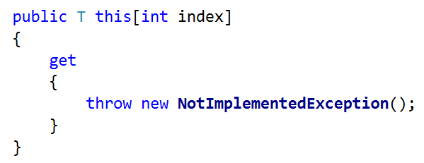

* The algorithm for **finding element by index** in a binary search tree is described here: <http://stackoverflow.com/a/2329236>
* Make sure the new functionality does not break the old one! (Rerun the unit tests from the AVL tree lab)